Life Science Syllabus
January

Before Coming to
Class on This Date: Please Have This Done:
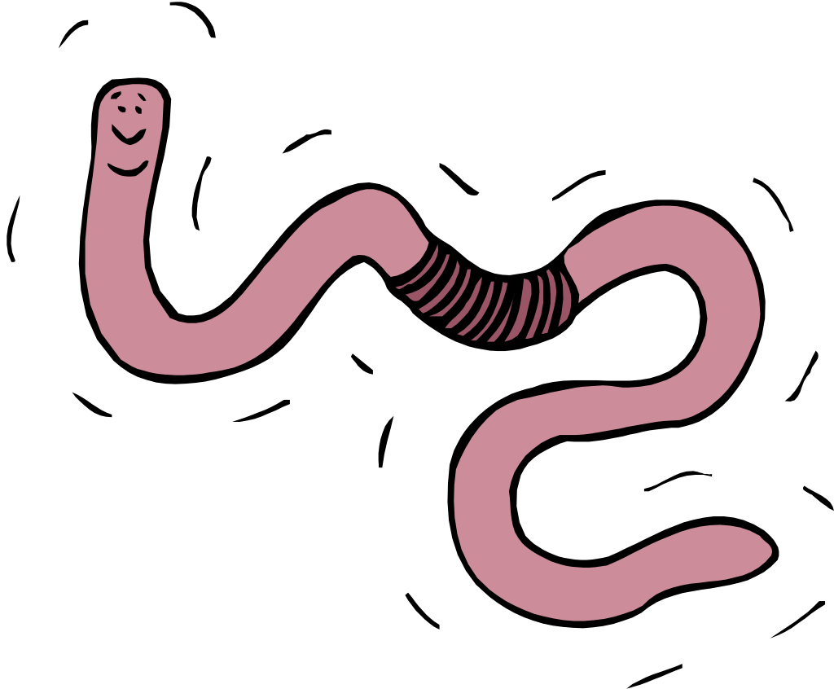
T | 1/6/15 | Read pages 16-22 (Chapter 1)  Complete Application 1b on lab page 3
TH | 1/8/15 | Complete Application 1c on lab pages 5-7  Be sure that you have downloaded and printed the Science Project packet from my Weebly page. We’ll be discussing it in class today—BRING IT WITH YOU!!!:)
T | 1/13/15 | Read pages 276-286  Answer Q 2,4,6 P279  Complete Application 13C on lab pgs 209-211
TH | 1/15/15 | Read pages 287-293  Answer Q 1,2,4,5,7, pg 289  Answer Q 3-5 pg 293  Science Project: Ideas due (see Packet)
T | 1/20/15 | Read pages 293-296  Answer questions 1-3,6-8 pg 296  Complete Application 13D on lab pages 213-214
TH | 1/22/15 | TEST Online-Chpt 13  Read pages 302-306  Complete Application 14A lab page 221  Science Project: Four sources due (see packet)
T | 1/27/15 | Read pages 306-312  Answer Q 1,3,5,6,7,9 page 313  Complete Application 14B on labe page 223  Bring some animal hair if you have it :)
TH | 1/29/15 | TEST Online -Chpt 14  Read pages 318-325  Answer Q 1,4,6,7,9,11 p 325

