P.E.P.
Earth/Space Science Syllabus
October

Before Coming to
Class on This Date: Please Have This Done:

T | 9/30/14 | TEST Online – Ch 5 (www.classmarker.com)  Read pages 122-129  Answer Q 2, 4, 5, 6 – 6A, Pg 126  Answer Q1, 2, 3, 4, 5 – 6B, Pg 130  Scientist Project – Submit 2 pages of research on the life of your scientist and 2 pages of  research on their discovery or invention. Cite your sources.
R | 10/2/14 | Read pages 130-141  Answer Q 1, 2, 3, 4, 5, 6 – 6C, Pg 133  Answer Q 1, 2, 4, 6, 8 – 6D, Pg 140  Lab 6C – Pgs 65-68 of lab book [KMZ file will be on Weebly]
T | 10/7/14 | TEST Online – Ch 6 (www.classmarker.com)  Read pages 144-156  Answer Q 1, 3, 4, 5 – 7A, Pg 149  Answer Q 2, 3, 4, 7 – 7B, Pg 156  Scientist Project – One paragraph introducing your project
R | 10/9/14 | Read pages 156-162  Answer Q 1, 2, 3, 6, 7, 8 – 7C, Pg 161
END OF THE FIRST QUARTER
T | 10/14/14 | TEST Online – Ch 7 (www.classmarker.com)  Read pages 166-179  Answer Q 2, 4, 5, 6, 8 – 8A, Pg 174  Answer Q 1, 2, 3, 4, 6 – 8B, Pg 180  Lab 8A – pgs 81-84 [KMZ file will be on Weebly]  Scientist Project – Start working on your demonstration at home
R | 10/16/14 | Read pages 180-186  Answer Q 1, 2, 3, 4, 5, 6 – 8C, Pg 187  Lab 8B – pgs 85-89
T | 10/21/14 | TEST Online – Ch 8 (www.classmarker.com)  Read pages 192-201  Answer Q 1, 2, 4, 5, 6, 9 – 9A, Pg 195  Answer Q 2, 3, 4, 5, 6, 8, 10 – 9B, Pg 201  Lab 9A – pgs 91-93 [Use only sugar and Epsom salts]  E-mail a photo of your crystals to me  Scientist Project – At least 3 paragraphs discussing your live interview
R | 10/23/14 | Read pages 202-210  Answer Q 1, 2, 3, 4, 5, 6, 7 – 9C, Pg 210
T | 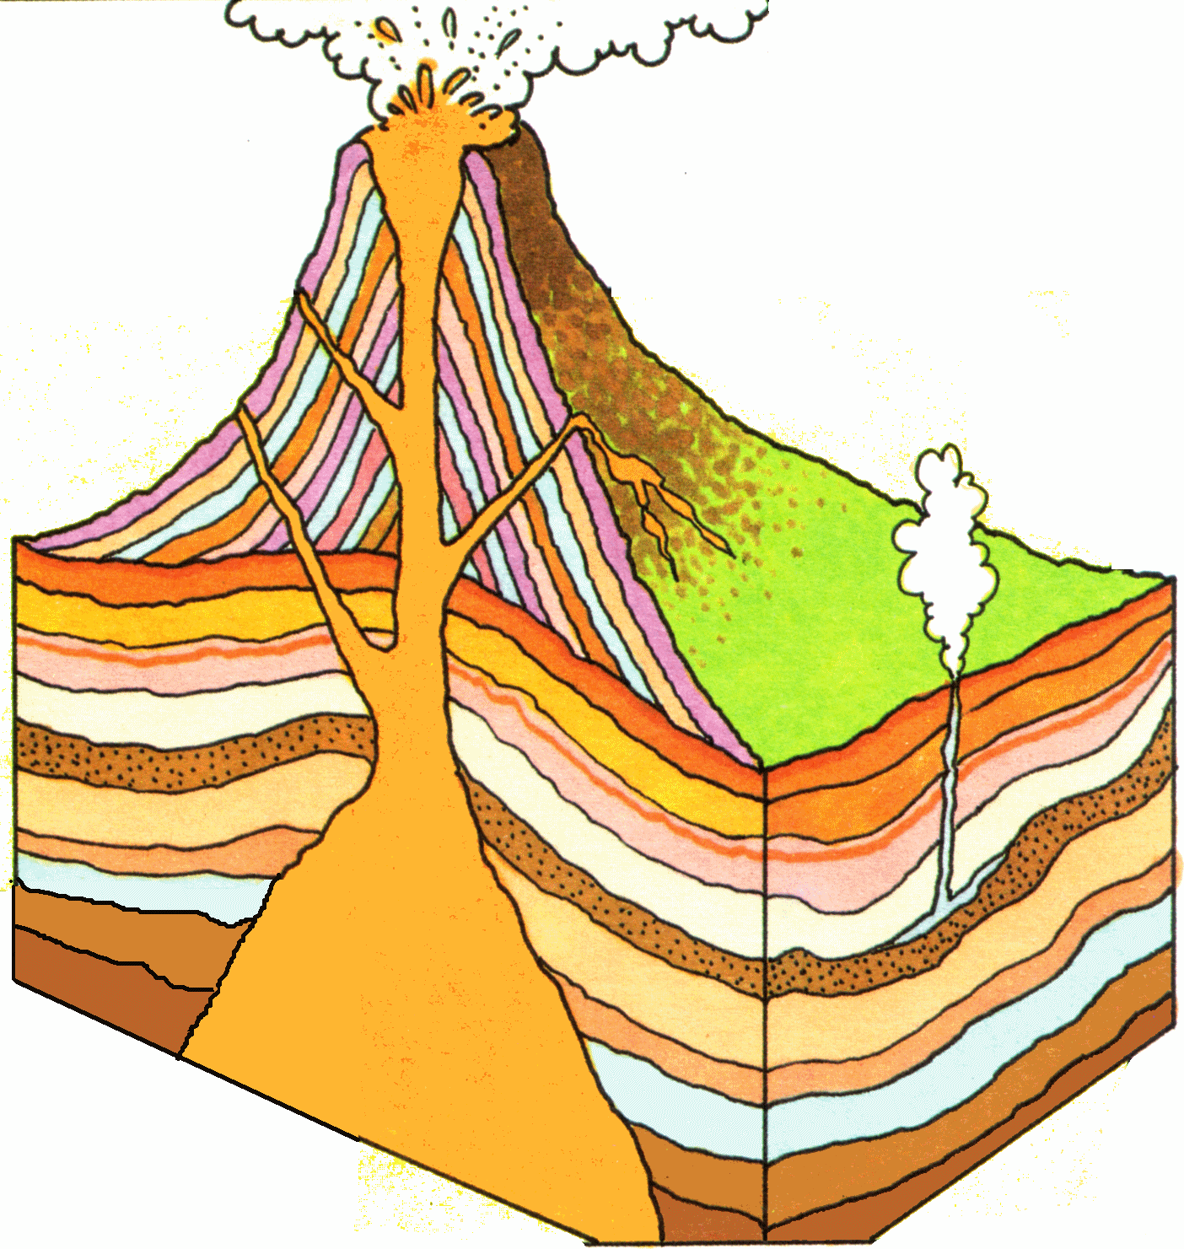  10/28/14 | TEST Online – Ch 9 (www.classmarker.com)  Read pages 214-221  Answer Q 1, 3, 4, 5, 6 – 10A, Pg 217  Answer Q 1, 2, 4, 5, 6, 8 – 10B, Pg 221
R | 10/30/14 | Read pages 221-227  Answer Q 1, 2, 3, 6, 7, 8 – 10C, Pg 227

